STA 111: DESCRIPTIVE STATISTICS
Class Activity
Stem plots, histograms and frequency polygons in R and Python

Before you start
This will show you how to do the three class activity questions with code. Each question is done twice, once in R and once in Python. Use whichever language your, or try both and compare.

What you need
- R: install R and RStudio. No extra packages are needed for these questions.
- Python (recommended: Google Colab): you only need a web browser and a Google (Gmail) account. Nothing to install, and numpy and matplotlib are already included. See the Colab guide on the next page.
- Python (other options): Anaconda (Jupyter Notebook or Spyder) also includes numpy and matplotlib. With a plain Python installation, run pip install numpy matplotlib once.

The 4-step routine (use it every time)
- Step 1: Enter the data exactly as it appears on the slide.
- Step 2: Check the data. Count the values and compare with the slide (30, 40 and 44 for Questions 1, 2 and 3).
- Step 3: Build the plot by running the code.
- Step 4: Interpret it. Write a sentence about what the plot shows. A plot with no interpretation is only half an answer.

Common mistakes
Typing the data wrongly. Always check the count first (Step 2). Most wrong answers start here.
In R, # starts a comment. Text without it is read as code and gives an error.
In Python, indentation matters: keep the spaces inside the for loop exactly as shown.
Copy the code carefully and run it line by line the first time, so you see what each line does.

Running the Python code in Google Colab
Google Colab runs Python in your web browser. Follow these steps for each question.
- Open Colab and sign in. Go to colab.research.google.com and sign in with your Google (Gmail) account.
- Create a notebook. Click New notebook in the pop-up, or choose File → New notebook. You get an empty notebook with a code cell.
- Name it. Click the title at the top left (it says Untitled0.ipynb) and rename it, for example STA111_Q1_YourName. Keep the .ipynb ending.
- Paste the code. Copy the Python code for one question from this handout (not the R code) and paste it into the cell. Use plain text; see the problems table below if you copy from Word.
- Run the cell. Click the round play button (a triangle) on the left of the cell, or press Shift + Enter. The first run may say "Connecting" for a few seconds. That is normal.
- Check your results. The printed output and the plot appear directly under the cell. The first number printed must be 30 for Question 1, 40 for Question 2 and 44 for Question 3. Then compare your output and plot with this handout.
- Do the next question. Click + Code at the top to add a new cell, paste the next question's code and run it. All three questions can be in one notebook.
- Save and submit. Colab saves your notebook to your Google Drive (in the Colab Notebooks folder). Press Ctrl + S to save. To get a file, choose File → Download → Download .ipynb. Submit in the format your lecturer asks for. If a PDF is required, print the page from your browser (Ctrl + P), choose Save as PDF, and check that the plots are visible.

If something goes wrong
What you see | What to do
SyntaxError or strange characters | Curly quotes copied from Word cause this. Replace them with straight quotes (" "), or copy the code from the PDF or a plain-text file.
IndentationError (Question 1) | The two lines inside the for loop must keep their 4 spaces exactly as shown.
NameError: name 'np' is not defined | The import lines at the top were not run. Run the whole cell again, or use Runtime → Run all.
The count is not 30, 40 or 44 | You have mistyped the data. Compare each value with the slide.
No plot appears | Check that the last line of the code is plt.show() and that you pasted the whole cell.
Session disconnected, or variables lost | Colab times out when idle. Click Runtime → Run all to rebuild everything. Your code is still saved.
ModuleNotFoundError | Very rare in Colab. Run !pip install numpy matplotlib in a new cell, then run your code again.

Remember
Colab needs an internet connection the whole time you work. Run your notebook in one sitting and download it before you log off.
Menu names can change slightly when Google updates Colab. If you cannot find an option, look under the File and Runtime menus.

Question 1: Stem plot and outliers
The data show the distances (in miles) from the homes of off-campus statistics students to the college. Create a stem plot using the data and identify any outliers.
Data (30 values): 0.5, 0.7, 1.1, 1.2, 1.2, 1.3, 1.3, 1.5, 1.5, 1.7, 1.7, 1.8, 1.9, 2.0, 2.2, 2.5, 2.6, 2.8, 2.8, 2.8, 3.5, 3.8, 4.4, 4.8, 4.9, 5.2, 5.5, 5.7, 5.8, 8.0
Idea: in a stem-and-leaf plot each value is split into a stem (here the whole miles) and a leaf (here the tenths digit). So 1.2 becomes stem 1, leaf 2. To test for outliers we use the 1.5 × IQR rule: a value is flagged if it is below Q1 − 1.5×IQR or above Q3 + 1.5×IQR.
R code
# Q1: Stem plot and outliers
distance <- c(0.5, 0.7, 1.1, 1.2, 1.2, 1.3, 1.3, 1.5, 1.5, 1.7,
1.7, 1.8, 1.9, 2.0, 2.2, 2.5, 2.6, 2.8, 2.8, 2.8,
3.5, 3.8, 4.4, 4.8, 4.9, 5.2, 5.5, 5.7, 5.8, 8.0)
length(distance) # check: must be 30

stem(distance) # stem-and-leaf plot

# Outlier test: the 1.5 x IQR rule
Q1 <- unname(quantile(distance, 0.25))
Q3 <- unname(quantile(distance, 0.75))
IQR_val <- Q3 - Q1
lower <- Q1 - 1.5 * IQR_val
upper <- Q3 + 1.5 * IQR_val
cat("Q1 =", Q1, " Q3 =", Q3, " IQR =", IQR_val, "\n")
cat("Lower fence =", lower, " Upper fence =", upper, "\n")
distance[distance < lower | distance > upper] # values outside the fences

# Second opinion: z-score of the largest value
(8.0 - mean(distance)) / sd(distance)

boxplot(distance, horizontal = TRUE,
main = "Distance to college (miles)", xlab = "Miles")

Expected output in R
[1] 30

The decimal point is at the |

0 | 57
1 | 12233557789
2 | 0256888
3 | 58
4 | 489
5 | 2578
6 |
7 |
8 | 0

Q1 = 1.5 Q3 = 4.25 IQR = 2.75
Lower fence = -2.625 Upper fence = 8.375
numeric(0)
[1] 2.742688

Python code
# Q1: Stem plot and outliers
import numpy as np
import matplotlib.pyplot as plt
from collections import defaultdict

distance = [0.5, 0.7, 1.1, 1.2, 1.2, 1.3, 1.3, 1.5, 1.5, 1.7,
1.7, 1.8, 1.9, 2.0, 2.2, 2.5, 2.6, 2.8, 2.8, 2.8,
3.5, 3.8, 4.4, 4.8, 4.9, 5.2, 5.5, 5.7, 5.8, 8.0]
print(len(distance)) # check: must be 30

# Stem-and-leaf plot: stem = whole miles, leaf = tenths digit
stems = defaultdict(list)
for v in sorted(distance):
stems[int(v)].append(round((v - int(v)) * 10))

print("Key: 1 | 2 = 1.2 miles")
for s in range(min(stems), max(stems) + 1): # keeps empty stems 6 and 7
print(f"{s} | {''.join(str(leaf) for leaf in stems.get(s, []))}")

# Outlier test: the 1.5 x IQR rule
q1, q3 = np.percentile(distance, [25, 75])
iqr = q3 - q1
lower = q1 - 1.5 * iqr
upper = q3 + 1.5 * iqr
print("Q1 =", q1, " Q3 =", q3, " IQR =", iqr)
print("Lower fence =", lower, " Upper fence =", upper)
print([v for v in distance if v < lower or v > upper])

# Second opinion: z-score of the largest value
print((8.0 - np.mean(distance)) / np.std(distance, ddof=1))

plt.boxplot(distance, vert=False)
plt.title("Distance to college (miles)")
plt.xlabel("Miles")
plt.show()

Expected output in Python
30
Key: 1 | 2 = 1.2 miles
0 | 57
1 | 12233557789
2 | 0256888
3 | 58
4 | 489
5 | 2578
6 |
7 |
8 | 0
Q1 = 1.5 Q3 = 4.25 IQR = 2.75
Lower fence = -2.625 Upper fence = 8.375
[]
2.7426875551875596

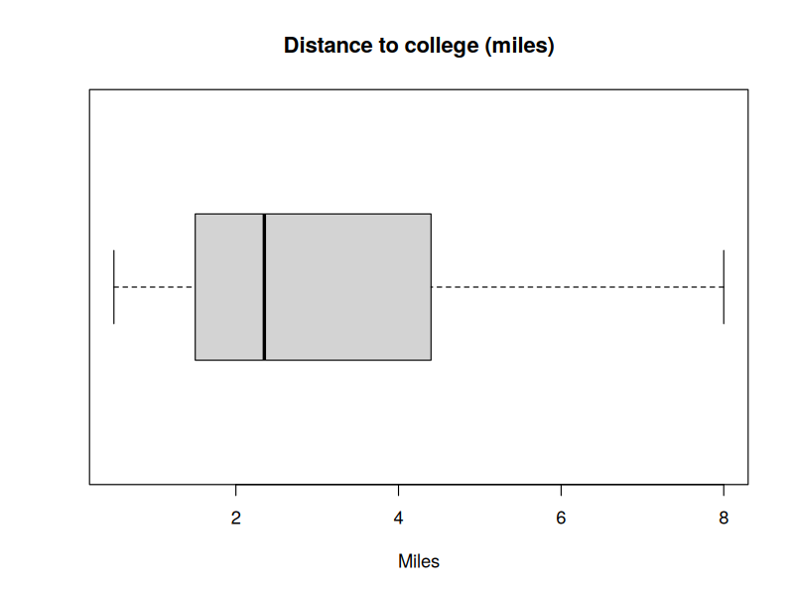  Output in R | 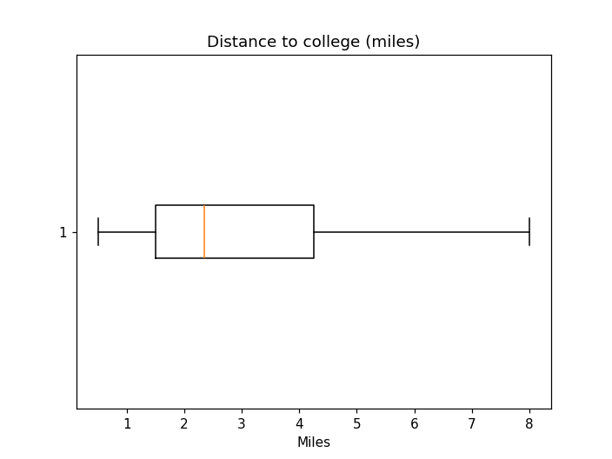  Output in Python

Reading the results
Apart from one student, everyone lives between 0.5 and 5.8 miles away, and stems 6 and 7 are empty. The value 8.0 stands alone, well apart from the rest.
The 1.5 × IQR rule gives an upper fence of 8.375, so 8.0 is not flagged by that rule. Its z-score is about 2.74, which is beyond 2 standard deviations but not 3.
Conclusion: 8.0 is a suspected (borderline) outlier. It looks unusual on the plot but does not cross the strict fence. State both facts in your answer.

Check yourself
- Delete the 8.0 and re-run. What happens to the mean? (It drops from 2.89 to about 2.71.)
- Why do R and Python give the same quartiles here? (Both use the same default method.)

Question 2: Histogram with frequency polygon (discrete data)
In a survey, 40 people were asked how many times per year they had their car in the shop for repairs. Draw a frequency polygon overlay on a histogram.
# of times | Frequency (f)
0 | 7
1 | 10
2 | 14
3 | 9

Idea: the table gives values and their frequencies, so we first rebuild the 40 raw observations with rep() in R or np.repeat() in Python. Each bar is centred on a whole number, so the class edges are at −0.5, 0.5, 1.5, 2.5 and 3.5. The frequency polygon joins the tops of the bars, with extra zero-frequency points at −1 and 4 so the line comes down to the axis at both ends.
R code
# Q2: Histogram with frequency polygon (discrete data)
x <- c(0, 1, 2, 3) # number of repairs
f <- c(7, 10, 14, 9) # frequencies

data <- rep(x, times = f) # rebuild the raw observations
length(data) # check: must be 40

hist(data, breaks = seq(-0.5, 3.5, by = 1), col = "lightblue",
main = "Car repairs per year", xlab = "Number of times",
ylab = "Frequency", xlim = c(-1.5, 4.5))

# polygon: join the bar tops, with zero-frequency points at -1 and 4
lines(c(-1, x, 4), c(0, f, 0), type = "o", col = "red", lwd = 2, pch = 16)

Expected output in R (the plot is shown below)
[1] 40

Python code
# Q2: Histogram with frequency polygon (discrete data)
import numpy as np
import matplotlib.pyplot as plt

x = np.array([0, 1, 2, 3]) # number of repairs
f = np.array([7, 10, 14, 9]) # frequencies

data = np.repeat(x, f) # rebuild the raw observations
print(len(data)) # check: must be 40

plt.hist(data, bins=np.arange(-0.5, 4, 1), color="lightblue",
edgecolor="black")

# polygon: join the bar tops, with zero-frequency points at -1 and 4
plt.plot(np.r_[-1, x, 4], np.r_[0, f, 0], "o-", color="red", linewidth=2)

plt.title("Car repairs per year")
plt.xlabel("Number of times")
plt.ylabel("Frequency")
plt.xlim(-1.5, 4.5)
plt.show()

Expected output in Python (the plot is shown below)
40

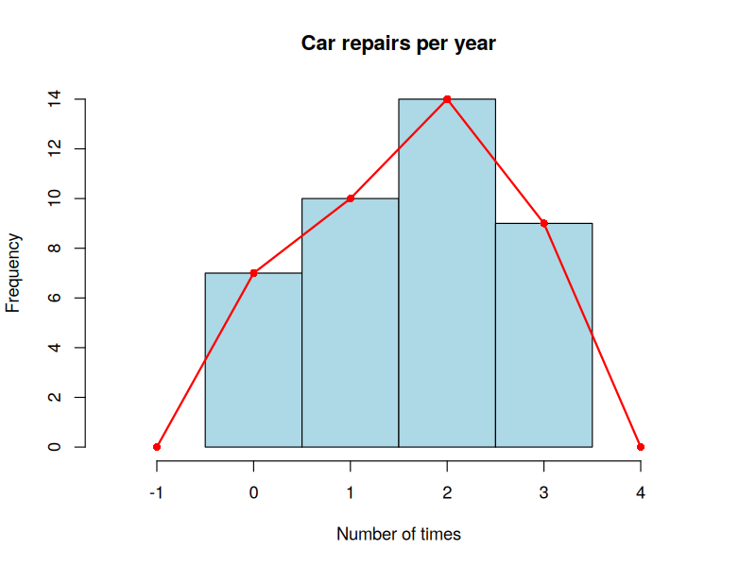  Output in R | 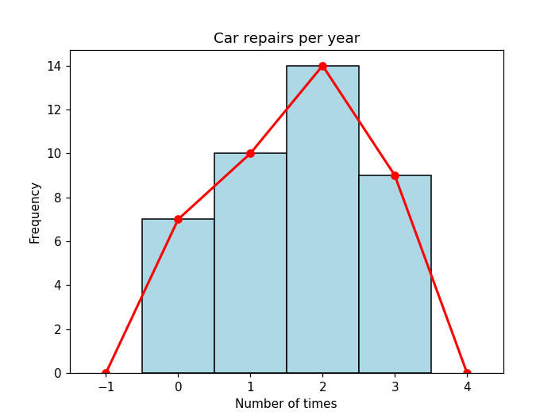  Output in Python

Tips
In R use type = "o" for the line. type = "b" leaves small gaps around each point.
Interpretation: 2 repairs per year is the most common result (14 of the 40 people), followed by 1 repair (10 people). Only 7 people had no repairs at all.

Question 3: Histogram and polygon (grouped data)
Construct a frequency polygon and a histogram using the ages at presidents' inauguration in the table below.
Class (ages) | Frequency (f)
42 – 46 | 4
47 – 51 | 11
52 – 56 | 14
57 – 61 | 9
62 – 66 | 4
67 – 71 | 2

Idea: this question has two new ideas. Class boundaries close the gaps between classes (46 and 47) by going half a unit each way: 41.5, 46.5, 51.5 … 71.5. The class mark is the midpoint, (lower + upper) ÷ 2, giving 44, 49, 54, 59, 64, 69. Bars are drawn on the boundaries and the polygon joins the class marks. Add an empty class at each end (marks 39 and 74) so the polygon returns to zero.
R code
# Q3: Histogram with frequency polygon (grouped data)
f <- c(4, 11, 14, 9, 4, 2)
lower_lim <- c(42, 47, 52, 57, 62, 67)
upper_lim <- c(46, 51, 56, 61, 66, 71)
sum(f) # check: must be 44

boundaries <- seq(41.5, 71.5, by = 5) # class boundaries
mid <- (lower_lim + upper_lim) / 2 # class marks
mid

ages <- rep(mid, times = f) # rebuild data using class marks
hist(ages, breaks = boundaries, col = "lightblue",
main = "Age at inauguration", xlab = "Age (years)",
ylab = "Frequency", xlim = c(36.5, 76.5), ylim = c(0, 16),
xaxt = "n")
axis(1, at = boundaries)

# polygon: join class marks, with empty classes at 39 and 74
lines(c(39, mid, 74), c(0, f, 0), type = "o", col = "red", lwd = 2, pch = 16)

Expected output in R (the plot is shown below)
[1] 44
[1] 44 49 54 59 64 69

Python code
# Q3: Histogram with frequency polygon (grouped data)
import numpy as np
import matplotlib.pyplot as plt

f = np.array([4, 11, 14, 9, 4, 2])
lower_lim = np.array([42, 47, 52, 57, 62, 67])
upper_lim = np.array([46, 51, 56, 61, 66, 71])
print(f.sum()) # check: must be 44

boundaries = np.arange(41.5, 72, 5) # class boundaries
mid = (lower_lim + upper_lim) / 2 # class marks
print(mid)

ages = np.repeat(mid, f) # rebuild data using class marks
plt.hist(ages, bins=boundaries, color="lightblue", edgecolor="black")

# polygon: join class marks, with empty classes at 39 and 74
plt.plot(np.r_[39, mid, 74], np.r_[0, f, 0], "o-", color="red", linewidth=2)

plt.xticks(boundaries)
plt.title("Age at inauguration")
plt.xlabel("Age (years)")
plt.ylabel("Frequency")
plt.xlim(36.5, 76.5)
plt.ylim(0, 16)
plt.show()

Expected output in Python (the plot is shown below)
44
[44. 49. 54. 59. 64. 69.]

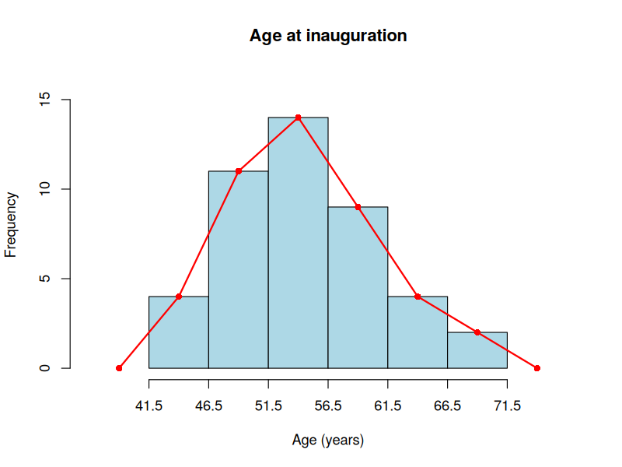  Output in R | 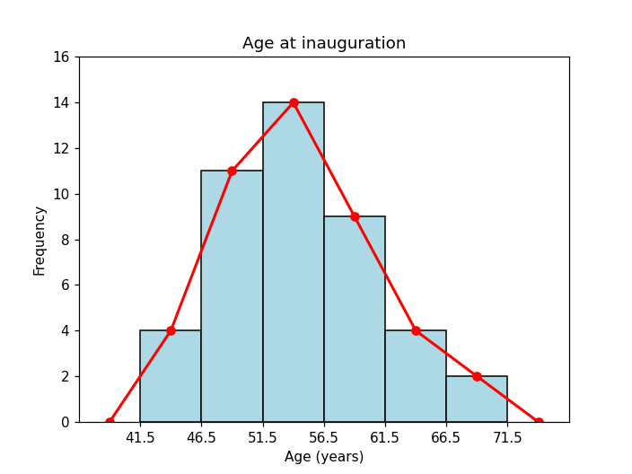  Output in Python

Reading the results
The distribution is roughly symmetric and slightly skewed to the right.
The modal class is 52 – 56, with 14 presidents. Most presidents were inaugurated between ages 47 and 61 (11 + 14 + 9 = 34 of the 44).
Your turn: change the boundaries to make 3 wider classes, re-run, and write two sentences comparing the new histogram with this one.

